**22AIE303 DBMS**

**LABSHEET 1**

Date:24/9/2024

**Abhiram A S  
AM.EN.U4AIE22002**

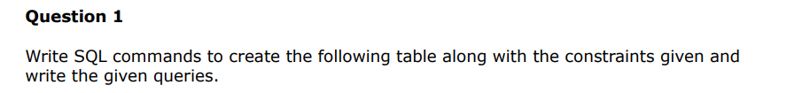

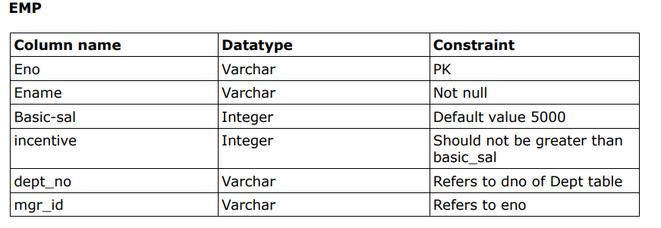

**CREATE TABLE EMP(**

**eno VARCHAR PRIMARY KEY,**

**ename VARCHAR NOT NULL,**

**basic-sal INT DEFAULT '5000',**

**incentive INT CHECK(incentive <= basic_sal),**

**dept_no VARCHAR,**

**mgr_id VARCHAR,**

**FOREIGN KEY dept_no REFERENCES DEPT(dno),**

**FOREIGN KEY mgr_id REFERENCES EMP(eno)**

**);**

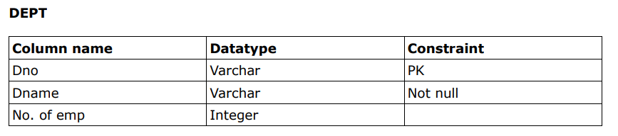

**CREATE TABLE DEPT(**

**dno VARCHAR PRIMARY KEY,**

**dname VARCHAR NOT NULL,**

**no_of_employees INT**

**);**



**ALTER TABLE EMP ADD JoiningDate DATE NOT NULL;**



**ALTER TABLE DEPT ADD HOD VARCHAR, ADD FOREIGN KEY (HOD) REFERENCES EMP(eno);**



**SELECT eno FROM EMP WHERE dept_no = 'D1';**



**SELECT * FROM DEPT;**



**SELECT eno, ename, joiningdate FROM EMP;**

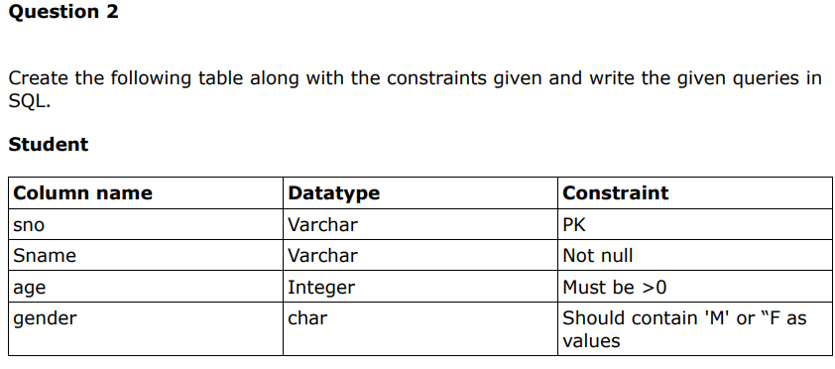

**CREATE TABLE STUDENT(**

**sno VARCHAR PRIMARY KEY,**

**sname VARCHAR NOT NULL,**

**age INT CHECK(age > 0),**

**gender CHAR CHECK(gender IN ('M','F'))**

**)**

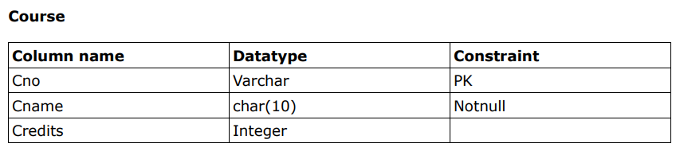

**CREATE TABLE COURSE(**

**cno VARCHAR PRIMARY KEY,**

**canme CHAR(10) NOT NULL,**

**credits INT**

**)**

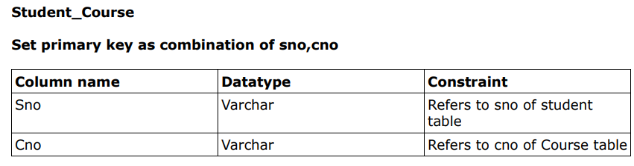

**CREATE TABLE Student_Course (**

**sno VARCHAR,**

**cno VARCHAR,**

**PRIMARY KEY (sno, cno),**

**FOREIGN KEY (sno) REFERENCES STUDENT(sno),**

**FOREIGN KEY (cno) REFERENCES COURSE(cno)**

**);**



**ALTER TABLE COURSE**

**ALTER COLUMN cname TYPE VARCHAR;**



**ALTER TABLE COURSE**

**ADD CONSTRAINT check_credits CHECK(credits > 0)**



**ALTER TABLE Student**

**ADD COLUMN dob DATE,**

**ADD COLUMN cgpa DECIMAL;**



**ALTER TABLE STUDENT**

**DROP COLUMN age;**



**SELECT dob,sno FROM STUDENT WHERE sname = 'Rahul'**

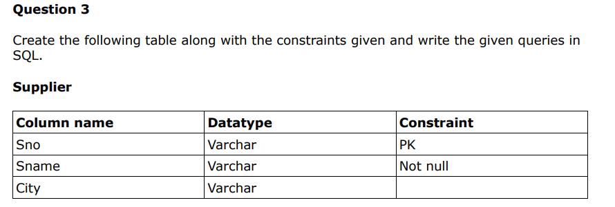

**CREATE TABLE supplier(**

**sno VARCHAR PRIMARY KEY,**

**sname VARCHAR NOT NULL,**

**CITY VARCHAR**

**);**

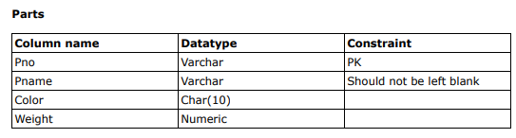

**CREATE TABLE parts(**

**pno VARCHAR PRIMARY KEY,**

**pname VARCHAR NOT NULL,**

**color CHAR(10),**

**weight NUMERIC**

**);**

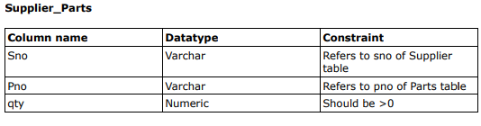

**CREATE TABLE supplier_parts(**

**sno VARCHAR,**

**pno VARCHAR,**

**qty NUMERIC,**

**CHECK (qty > 0),**

**FOREIGN KEY (sno) REFERENCES supplier(sno),**

**FOREIGN KEY (pno) REFERENCES parts(pno)**

**);**



**ALTER TABLE supplier_parts**

**ADD COLUMN date DATE;**



**ALTER TABLE supplier_parts**

**RENAME TO parts_supplied;**



**SELECT sname FROM supplier WHERE city LIKE 'T%A';**



**DROP TABLE parts_supplied;**



**ALTER TABLE supplier**

**ALTER COLUMN sname TYPE VARCHAR(25);**



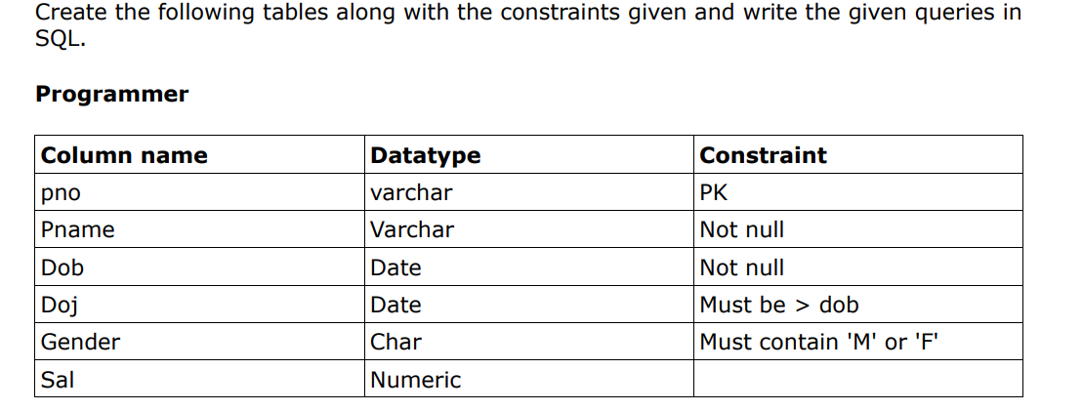

**CREATE TABLE programmer(**

**pno VARCHAR PRIMARY KEY,**

**pname VARCHAR NOT NULL,**

**dob DATE NOT NULL,**

**doj DATE NOT NULL,**

**gender CHAR,**

**sal NUMERIC,**

**CONSTRAINT doj_check CHECK(doj > dob),**

**CONSTRAINT gender_check CHECK(gender IN('M','F'))**

**);**

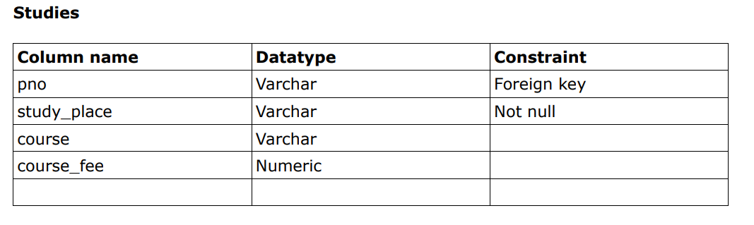

**CREATE TABLE studies(**

**pno VARCHAR,**

**study_place VARCHAR,**

**course VARCHAR,**

**course_fee NUMERIC,**

**FOREIGN KEY(pno) REFERENCES programmer(pno)**

**);**

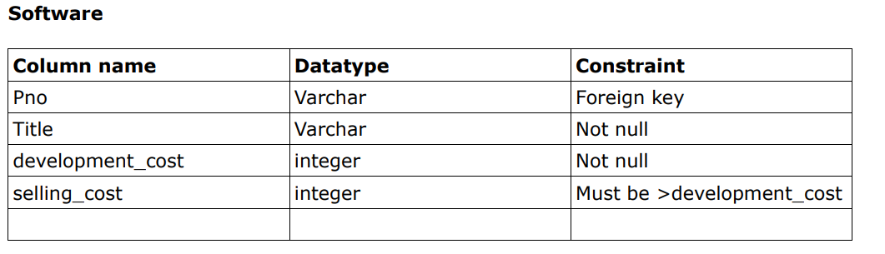

**CREATE TABLE software(**

**pno VARCHAR,**

**title VARCHAR NOT NULL,**

**development_cost INT NOT NULL,**

**selling_cost INT,**

**FOREIGN KEY (pno) REFERENCES programmer(pno),**

**CONSTRAINT selling_check CHECK(selling_cost > development_cost)**

**);**



**ALTER TABLE software**

**ADD COLUMN sw_id VARCHAR NOT NULL,**

**ADD COLUMN developed_in VARCHAR NOT NULL;**

**id**



**ALTER TABLE software**

**ADD CONSTRAINT prime PRIMARY KEY(sw_id);**



**ALTER TABLE software**

**DROP CONSTRAINT selling_check;**



**ALTER TABLE programmer**

**RENAME COLUMN doj TO hire_date;**